BIODATA

Name : Himakshi Seal Sarma 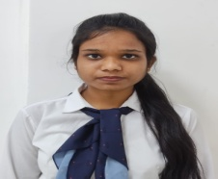
Father’s name : Dibyakanti Sarma
Mother’s name : Sila Rani Seal
Gender : Female
Language known : English , Assamese , Hindi
Permanent Address : Tikrikilla , West Garo Hills , Meghalaya
Email Id : sarmahimakshi15@gmail.com
Mobile No : 9366385723
Category : General
Religion : Hinduism
Nationality : Indian
Educational Qualification :
Name of the Exam | Year of Pass | Board /University Name | Specialization | Percentage
SSLC | 2016 | MBOSE |  | 54%
HSLC | 2018 | MBOSE |  | 56%
Under Graduate /Degree | 2021 | University of Science & Technology Meghalaya | Microbiology | 6.29
Post Graduate / Master degree | 2023 | Royal Global University | Microbiology | 7.27
Internship (1months) | 2021 | Guwahati Neurological Research Centre, Assam | Microbiology
Computer Education Centre (3 months) | 2014 | Institute of Computer Science and Technology ,Guwahati | CCA | Grade ‘A’

Declaration :
I hereby declare that all the information provided here is true to the best of my knowledge.
Date :
Place : Signature:

